Compiler Construction
SIR ABDUL REHMAN QURESHI

NAME: MUREED ABBAS
CLASS: BSCS V
SECTION: A
CMS ID : 023-24-0439
MUREED
LAB : Three

1. Introduction
This lab focuses on lexical analysis and regular expressions. A lexical analyzer, also called a scanner, is the first phase of a compiler. It reads source-code characters, groups them into lexemes, and produces tokens. Regular expressions describe the patterns of common tokens such as identifiers, numbers, keywords, and operators.
In this lab, I wrote regular expressions for different token descriptions, tested identifiers using Python's re.fullmatch(), and implemented a small rule-based lexical analyzer. The lexer was then extended to recognize keywords, relational operators, comments, and line numbers.

2. Exercise 1 — Write the Regex
Q1. Identifier starting with a lowercase letter:
[a-z][A-Za-z0-9]* Examples: hello, student1, abc123
Q2. Binary number:
[01]+
String | Result | Reason
Lab4 | Accepted | Starts with a letter and is followed by letters/digits.
4Lab | Rejected | Starts with a digit; the first character must be a letter.
total_sum | Rejected | Underscore is not allowed by the given pattern.
Examples: 0, 1, 101, 11001
Q3. Valid C variable name:
[A-Za-z_][A-Za-z0-9_]*
Examples: name, _total, student1, student_name
Q4. Email-like username:
[a-z]+\.[a-z]+
Examples: faryal.shamsi, ali.khan, saifullah.ramzan
Q5. Comment between /* and */:
/\*(?:[^*]|\*(?!/))*\*/
The expression matches /* ... */ without allowing another */ inside.

3. Exercise 2 — Trace the Regex
Given regex:
[A-Za-z][A-Za-z0-9]*
"" (empty string) | Rejected | The pattern requires a starting letter.

Exercise 3 — Test with Python
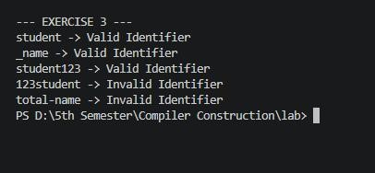

Exercise 4 — Extend the Mini Lexer
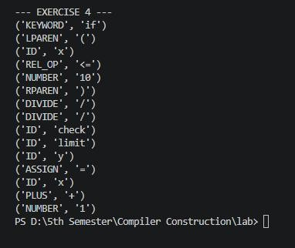

Exercise 5 — Challenge
